DSA05 – Query Processing for Data Science

NAME:V.Tejaswini

REG NO:192424360

1.Write a Pandas program to select the distinct department id from employees file.
Aim
To write a Pandas program to select the distinct department IDs from the employees file.

Algorithm:
  - Import the Pandas library.
  - Create a DataFrame containing the department data.
  - Select the DEPARTMENT_ID column.
  - Find the unique department IDs using the appropriate Pandas function.
  - Display the distinct department IDs.

Code:
import pandas as pd
df = pd.read_csv("exp1 data.csv") print("Distinct Department IDs")
print(df["DEPARTMENT_ID"].drop_duplicates())

Output:

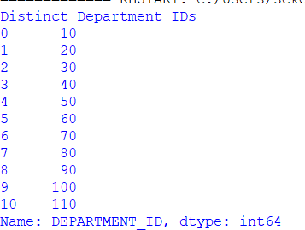

Write a Pandas program to display the IDs of employees who have done two or more jobs in the past.
Aim
To write a Pandas program to display the employee IDs of employees who have done two or more jobs in the past.

Algorithm:
  - Import the Pandas library.
  - Create a DataFrame containing the job history data.
  - Group the records based on EMPLOYEE_ID.
  - Count the number of jobs for each employee.
  - Filter employees having two or more job records.
  - Display the employee IDs.

Pseudo Code
import pandas as pd
df = pd.read_csv("exp2_data.csv")
result = df.groupby("EMPLOYEE_ID").size() print("Employees with two or more jobs") print(result[result >= 2])
Output:
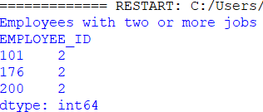

Write a Pandas program to display the details of jobs in descending sequence on job title.
Aim
To write a Pandas program to display the job details in descending order based on the job title.

Algorithm:
  - Import the Pandas library.
  - Create a DataFrame containing the job details.
  - Sort the DataFrame using the JOB_TITLE column in descending order.
  - Display the sorted DataFrame.

Code:
import pandas as pd
df = pd.read_csv("exp2_data.csv")
result = df.sort_values(by="JOB_TITLE", ascending=False) print(result)

Output:
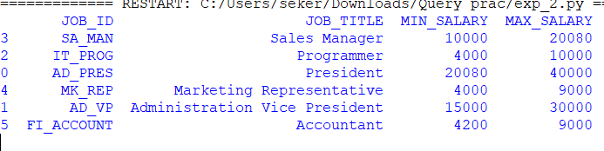

Write a Pandas program to create a line plot of the historical stock prices of Alphabet Inc. between two specific dates.

Aim:
To create a line plot showing the historical stock closing prices of Alphabet Inc. between two specific dates using Pandas and Matplotlib.

Algorithm:
  - Import Pandas and Matplotlib.
  - Read the CSV file.
  - Convert the Date column to datetime format.
  - Filter the data between the given dates.
  - Plot the closing prices as a line graph.
  - Display the graph.

Code:
import pandas as pd
import matplotlib.pyplot as plt

df = pd.read_csv("exp2_data.csv") df["Date"] = pd.to_datetime(df["Date"])

plt.plot(df["Date"], df["Close"]) plt.title("Alphabet Closing Price") plt.xlabel("Date") plt.ylabel("Close Price") plt.grid(True)
plt.show()

Output:
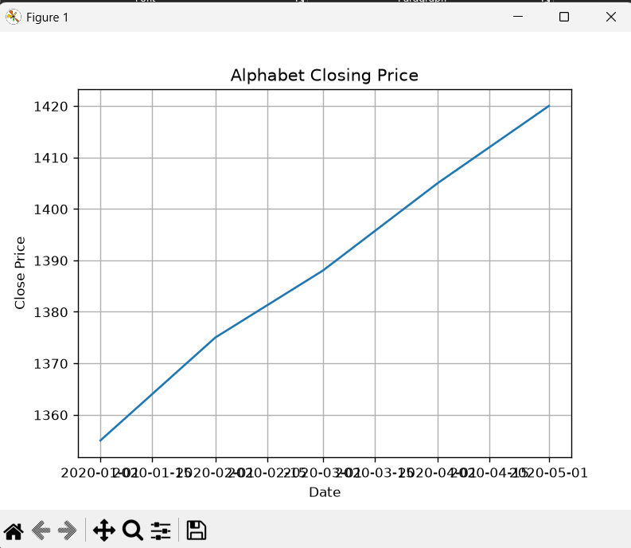

Write a Pandas program to create a bar plot of the trading volume of Alphabet Inc. stock between two specific dates.

Aim:
To create a bar plot showing the trading volume of Alphabet Inc. stock between two specific dates.

Algorithm:
  - Import Pandas and Matplotlib.
  - Read the CSV file.
  - Convert the Date column to datetime format.
  - Filter the required date range.
  - Create a bar chart using the Volume column.
  - Display the graph.

Code:

import pandas as pd
import matplotlib.pyplot as plt

df = pd.read_csv("exp2_data.csv") df["Date"] = pd.to_datetime(df["Date"]) plt.bar(df["Date"], df["Volume"])
plt.title("Alphabet Trading Volume") plt.xlabel("Date") plt.ylabel("Volume") plt.xticks(rotation=45)

plt.show()

Output:
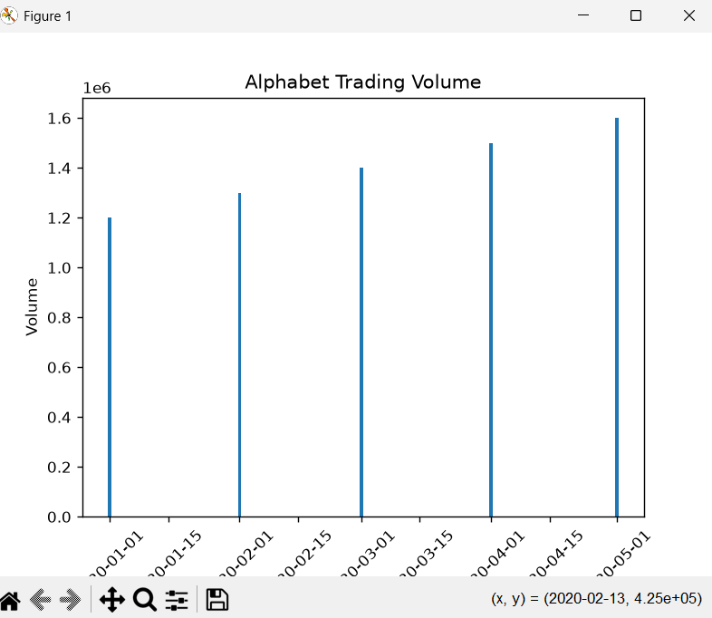

- Write a Pandas program to create a scatter plot of the trading volume/stock prices of Alphabet Inc. stock between two specific dates. alphabet_stock_data:

Aim:
To create a scatter plot of the trading volume and closing stock prices of Alphabet Inc. between two specific dates using Pandas and Matplotlib.

Algorithm:
  - Import the Pandas and Matplotlib libraries.
  - Read the Alphabet stock data from the CSV file.
  - Convert the Date column into datetime format.
  - Select the records between the required start and end dates.

  - Create a scatter plot using Close price and Volume.
  - Display the scatter plot.

Code:
import pandas as pd
import matplotlib.pyplot as plt

df = pd.read_csv("exp2_data.csv")
df["Date"] = pd.to_datetime(df["Date"], dayfirst=True) start_date = "2020-04-01"
end_date = "2020-04-30"
data = df[(df["Date"] >= start_date) & (df["Date"] <= end_date)] plt.figure(figsize=(8,5))
plt.scatter(data["Close"], data["Volume"])

plt.title("Alphabet Stock Price vs Trading Volume") plt.xlabel("Closing Stock Price") plt.ylabel("Trading Volume")

plt.grid(True) plt.show()

Output:

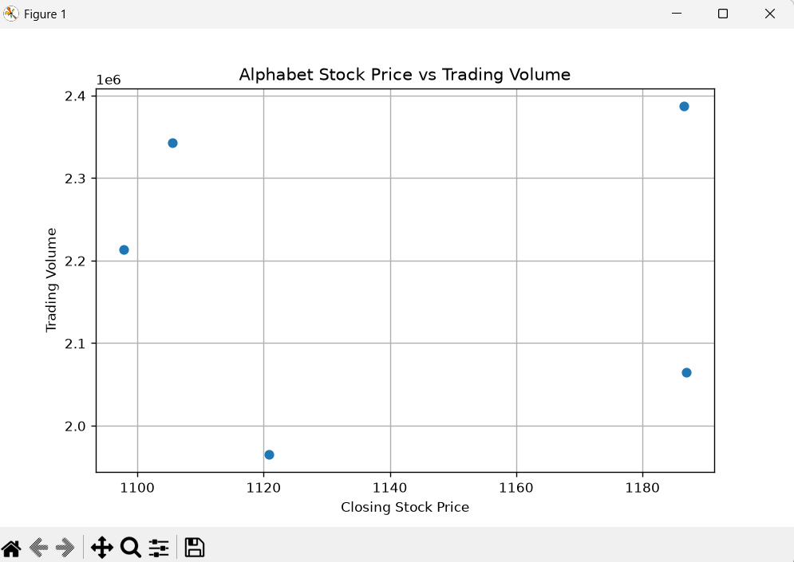

- Write a Pandas program to create a Pivot table and find the maximum and minimum sale value of the items.(refer sales_data table)

Aim:
To create a pivot table to find the maximum and minimum sale amount for each item.

Algorithm:
  - Import Pandas.
  - Read the sales data CSV file.
  - Create a pivot table using the Item column.
  - Apply the maximum and minimum aggregate functions on Sale_amt.
  - Display the pivot table.

Code:
import pandas as pd
df = pd.read_csv("exp2_data.csv") table = pd.pivot_table(df,
values="Sale_amt",

index="Item", aggfunc=["max","min"])

print(table)

Output:
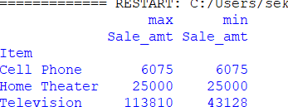

- Write a Pandas program to create a Pivot table and find the item wise unit sold. .(refer sales_data table)

Aim:
To create a pivot table showing the total units sold for each item.

Algorithm:
  - Import Pandas.
  - Read the sales data CSV file.
  - Create a pivot table using the Item column.
  - Calculate the sum of Units sold.
  - Display the result.

Code:
import pandas as pd
df = pd.read_csv("exp2_data.csv") table = pd.pivot_table(df,
values="Units",
index="Item", aggfunc="sum")

print(table)

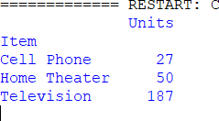
Output:

- Write a Pandas program to create a Pivot table and find the total sale amount region wise, manager wise, sales man wise. .(refer sales_data table)

Aim:
To create a pivot table showing the total sale amount based on Region, Manager, and Salesman.

Algorithm:
Import Pandas.
Read the sales data CSV file.
Create a pivot table using Region, Manager, and SalesMan as indexes. Calculate the total Sale_amt.
Display the pivot table.

Code:
import pandas as pd
df = pd.read_csv("exp2_data.csv") table = pd.pivot_table(df,
values="Sale_amt", index=["Region","Manager","SalesMan"], aggfunc="sum")

print(table)

Output:
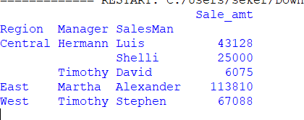

- Create a dataframe of ten rows, four columns with random values. Write a Pandas program to highlight the negative numbers red and positive numbers black.

Aim:
To create a DataFrame with 10 rows and 5 columns containing random values and highlight the negative numbers in red and positive numbers in black using Pandas.

Algorithm:
  - Import the Pandas and NumPy libraries.
  - Create a DataFrame with random values.
  - Define a function to assign colors based on the value.
  - Apply the function using DataFrame.style.applymap().

  - Display the styled DataFrame.

Code:
import pandas as pd import numpy as np

np.random.seed(10)

df = pd.DataFrame({ 'A': range(1,11),
'B': np.random.randn(10),
'C': np.random.randn(10),
'D': np.random.randn(10),
'E': np.random.randn(10)
})

def color_negative(val): if val < 0:
return "color:red" else:
return "color:black"

styled_df = df.style.map(color_negative, subset=['B','C','D','E']) styled_df.to_html("output.html")
print("Output saved as output.html")

Output:
